# Project Name

Olympics History Data Runners-Up

# Prepared BY ( Team)

1- Omar Yasser Mohamed

2- Omar Mohsen Sayed

3- Ahmed Mahmoud Abdel Halim

4- Abdelrahman Osama Ahmed

5- Nada Mohamed Metwaly

**Supervised By ()**

Eng. / Kareem El Demerdash

**Group Code (**Data Analyst Specialist_CAI 1 _DAT 1 _G 7 e_)

# Table of contents

•**Executive Summary**

•**Introduction**

Overview of the Olympics Dataset

Mind map

•**Olympic athletics event dashboard**

Purpose and Goals of the Dashboard

•**Key Questions**

•**Key Performance Indicators (KPIs)**

Total Medals by Country

Top Athletes by Medal Count

Trends in Performance Over the Years

Most Successful Sports

•**Insights and Solutions**

Growth of Emerging Nations

Specialization in Niche Sports

Importance of Long-term Athlete Development

•**Recommendations**

Investing in Training & Facilities

Targeting Less Competitive Sports

Fostering Youth Development Programs

•**Conclusion**

# Executive Summary:

The Olympic Games are a global showcase of athletic excellence, representing not only the pinnacle of sports but also a reflection of global history, politics, and societal values. This dashboard provides a detailed analysis of data from the modern Olympics, covering the Games. It highlights key trends in medal distribution, country performance, sport-specific achievements, and athlete demographics.

# Key insights from the analysis include:

•Dominant Countries: The USA, China, and Russia consistently rank as top performers in terms of medal counts across various sports, with emerging nations closing the gap in recent years.

•Top Athletes: Standout athletes such as Michael Phelps and Usain Bolt dominate in swimming and track and field, respectively, showcasing individual athletic excellence.

•Sport-Specific Trends: Athletics, swimming, and gymnastics remain the most competitive and medal-rich sports, contributing significantly to the overall medal tallies of top-performing countries.

•Gender and Athlete Characteristics: The participation of women in the Olympics has steadily increased, reflecting broader societal shifts towards gender equality. Additionally, the analysis explores trends in physical attributes and demographics of medal-winning athletes.

# Introduction:

The modern Olympic Games, spanning from Athens 1896 to 2024, are far more

than just a quadrennial multi-sport event. They offer a unique lens through

which to examine global history, reflecting shifting geopolitical dynamics, the rise

of women s empowerment, and society's evolving values.

The Olympic Games bring together the world’s best athletes, offering a wealth of data on performance, trends, and outcomes.

Leveraging data analytics on this extensive dataset can provide valuable insights into athlete performance, country participation, and emerging trends over time.

# Objectives:

This project aims to analyze and extract insights from historical and current Olympic data to enhance decision-making, strategy formation, and trend forecasting.

# Purpose:

The purpose of this data analytics is to:

* Enhance decision-making for coaches, athletes, and organizers by providing actionable insights.
* Improve fan experience through tailored marketing and engagement strategies based on audience data.
* Optimize logistics by analyzing traffic patterns, event flow, and resource needs.
* Support athlete development by using data to identify performance gaps and training needs.

# Analyzing Steps:

By using Tableau with Power Query:

1. Data Collection
2. Data Cleaning and Preprocessing
3. Modeling and Prediction
4. Visualization and Reporting
5. Build an interactive dashboard
6. Propose solutions and recommendations.

•The mind map presents a summary of the history of the Olympics, with key points divided into the following sections: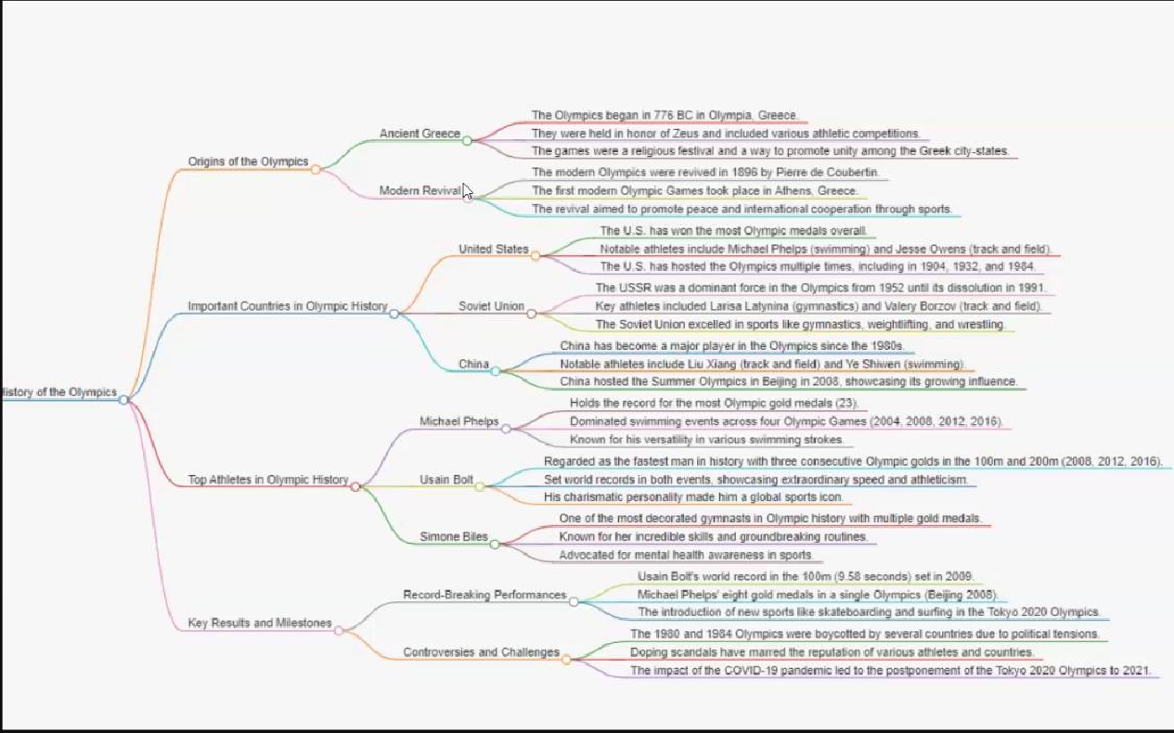

**Origins of the Olympics:**

•Ancient Greece: The Olympics began in 776 BC in Olympia, Greece, as a religious festival honoring Zeus, promoting unity among city-states through athletic competitions.

•Modern Revival: The modern Olympics were revived in 1896 by Pierre de Coubertin, aiming to promote peace and international cooperation through sports.

Important Countries in Olympic History:

•United States: The U.S. has won the most Olympic medals overall, with notable athletes like Michael Phelps and Jesse Owens. The U.S. has hosted the Olympics multiple times.

•Soviet Union: A dominant force from 1952 until its dissolution in 1991, excelling in sports like gymnastics and weightlifting.

•China: A major Olympic power since the 1980s, hosting the 2008 Olympics and producing athletes like Liu Xiang (track and field) and Ye Shiwen(swimming).

**Top Athletes in Olympic History:**

•Michael Phelps: Holds the record for the most Olympic medals (23), dominating swimming across four Games.

•Usain Bolt: Regarded as the fastest man in history, winning three consecutive Olympic golds in the 100m and 200m.

•Simone Biles: One of the most decorated gymnasts, known for groundbreaking routines and advocating for mental health in sports.

**Key Results and Milestones:**

•Record-Breaking Performances: Includes Usain Bolt's 100m world record and Phelps' eight gold medals in Beijing 2008.

•New Sports: Skateboarding and surfing were introduced in the Tokyo 2020 Olympics.

**Controversies and Challenges:**

•Political tensions led to boycotts in 1980 and 1984.

•Doping scandals have affected the reputation of various athletes and countries.

•The COVID-19 pandemic caused the postponement of the 2020 Tokyo Olympics to 2021.

**Key Questions:**

•Which Country Leads in Total Medals?

•Who Are the Top Medal-Winning Athletes?

•Which Sports Drive Medal Wins?

•How Do Regions Compare in Olympic Performance?

**Purpose and Goals of the Dashboard:**

The purpose of the dashboard is to provide a comprehensive and visually engaging analysis of Olympic Games data, offering insights into key trends and performance metrics over time. By analyzing historical data, the dashboard aims to help users explore:

•Medal Distribution: Understand which countries and athletes have excelled in various Olympic Games.

•Country Performance: Track the evolution of different nations' success across multiple Olympic events.

•Sport-Specific Trends: Identify which sports contribute the most to medal tallies and the dominance of specific countries in certain disciplines.

•Athlete Demographics: Analyze characteristics of Olympic athletes, such as gender, physical size, and other relevant factors.

•The overall goal is to provide users with a powerful tool to explore Olympic history, identify emerging patterns, and gain deeper insights into global athletic performance and societal trends through the lens of the Games.

**Key Performance Indicators (KPIs):**

**Total Medals by Country:**

•Let’s zoom into the thrilling world of medals at the Olympics it’s like diving into a treasure trove of athletic achievements! In our analysis, the USA emerges as the undisputed champ, clinching the most medals. Russia and Germany follow suit, securing their spots at second and third place on the podium. But here’s the twist: the dominance is not just in numbers but also in gender, with male athletes snagging a lion’s share of the victories. It’s like the USA is the powerhouse of the Olympic medal game, flexing its muscles through its male contenders.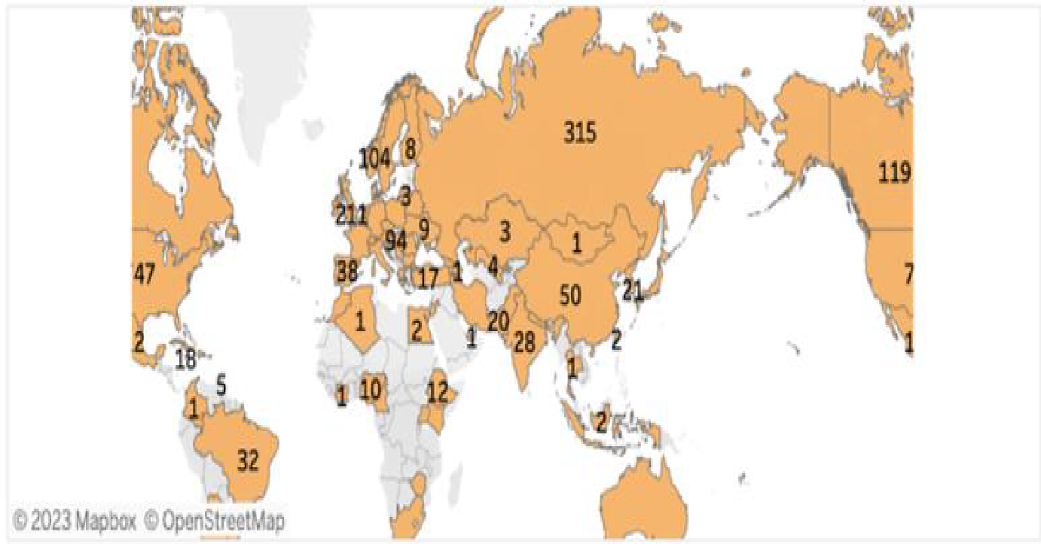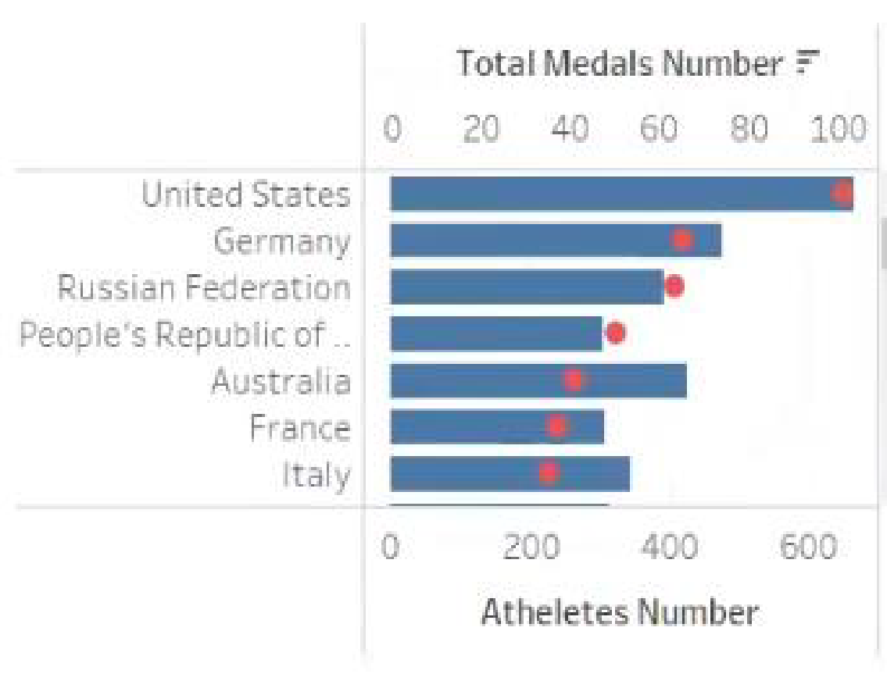

**Top Athletes by Medal Count:**

•Top Performing Athletes: Highlighting the athletes with the highest medal counts.

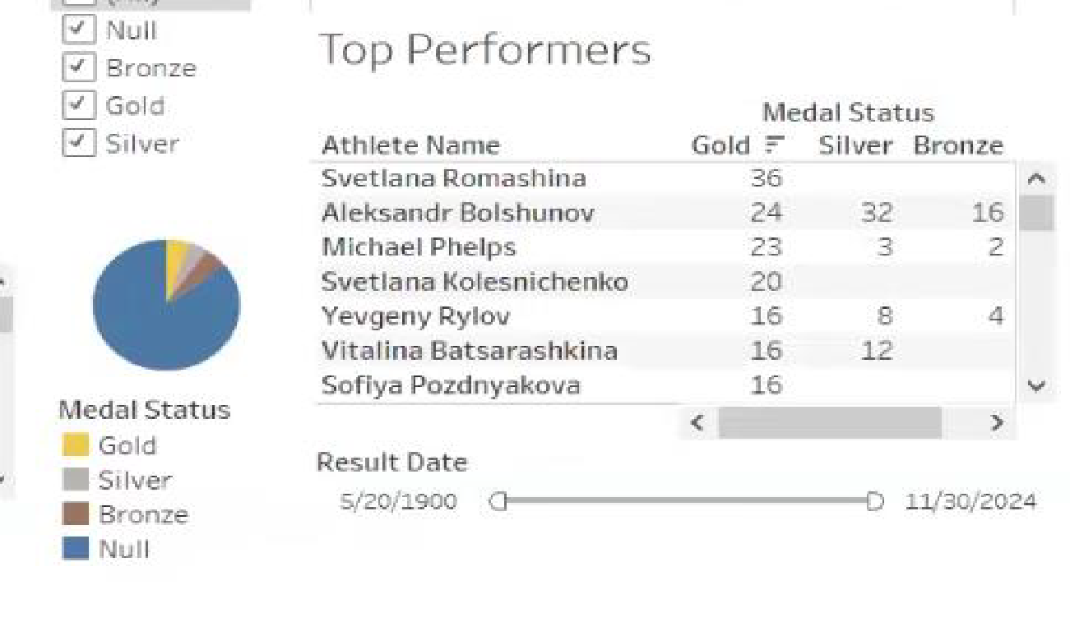

**Trends in Performance Over the Years:**

•Performance Trends by Year: Comparing how performance trends evolve across Olympic games.

•Athlete Performance Improvements: Track how individual athletes or teams have improved their performance over the years. For example, look at world records and personal bests set in different Olympics to see how performance levels have changed.

**Most Successful Sports:**

•Sports Performance: Analyzing which sports yield the most

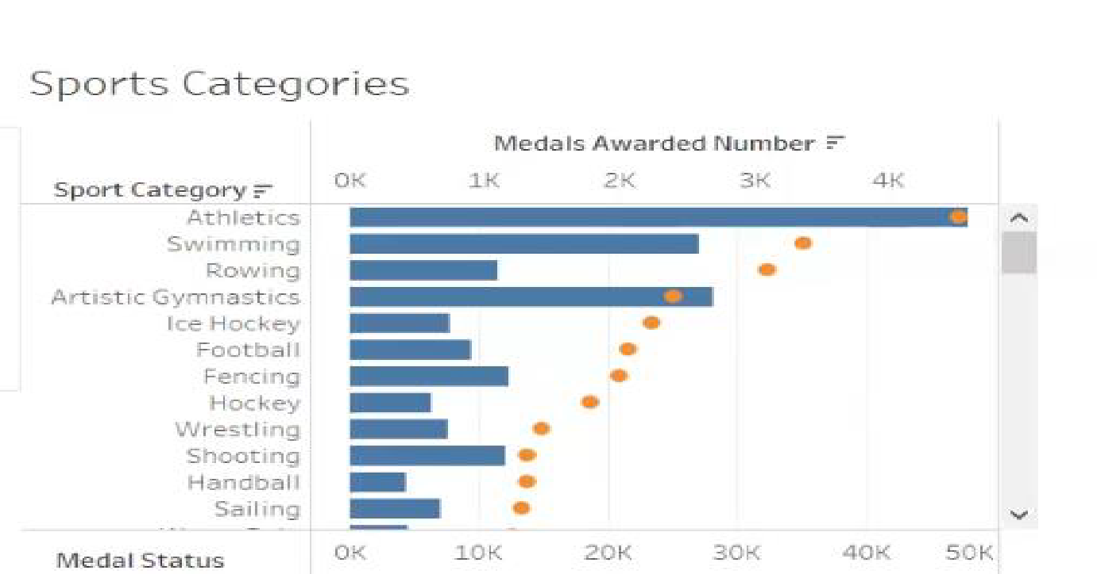

**Insights and Strategic Solutions:**

**Growth of Emerging Nations:**

•Key Insight: Emerging nations, such as China, have demonstrated impressive advancements in specific sports like diving and gymnastics. This rapid rise underscores the potential for targeted investments.

•Strategic Solution: To capitalize on this trend, countries should consider allocating additional resources and support to sports where they have shown emerging strength, fostering continued growth and potential dominance.

**Specialization in Niche Sports:**

•Key Insight: Countries such as Norway have achieved significant success in niche sports, such as skiing, where the level of competition is relatively lower.

•Strategic Solution: Nations aiming to enhance their Olympic performance might focus on developing expertise and competitive advantage in niche sports. This strategy could help them achieve higher rankings with more manageable competition.

**Importance of Long-term Athlete Development:**

•Key Insight: Exceptional athletes like Michael Phelps exemplify the impact of sustained and well-structured athlete development programs. These programs are crucial for nurturing talent and achieving excellence.

•Strategic Solution: Other countries should consider adopting and refining long-term athlete development programs modelled after successful examples. Investing in these programs can lead to substantial improvements in athlete performance and overall Olympic success.

**Investment in Training Facilities:**

•Recommendation: Countries with lower medal counts should prioritize the development of state-of-the-art training facilities and recruit experienced coaches.

•Rationale: High-quality training environments and expert guidance can significantly enhance athlete performance, providing them with the tools and support needed to excel on the global stage.

**Targeting Less Competitive Sports:**

•Recommendation: To increase the likelihood of winning medals, countries should focus on sports with fewer participants where competition is less intense.

•Rationale: By concentrating efforts on less crowded sports, nations can improve their medal chances and achieve more favourable results with a strategic approach.

Recommendations:

**Fostering Youth Development Programs:**

•Recommendation: Establish and expand youth Olympic programs inspired by successful models from countries like the USA and China.

•Rationale: Implementing robust youth development programs will lay a solid foundation for future success by nurturing young talent and ensuring a steady pipeline of skilled athletes.

**Conclusion:**

•The analysis of Olympic data reveals key insights into performance trends and success factors:

•Top Performers: The USA, China, and Russia lead in medal counts due to their strong athlete development and diverse sport investments.

•Star Athletes: Icons like Michael Phelps and Usain Bolt exemplify the impact of exceptional talent and rigorous training.

•Medal Contributions: Athletics, swimming, and gymnastics are major contributors to medal tallies.

•Emerging Nations: Countries like China are excelling in specific sports, indicating the potential for others to gain by focusing on niche areas.

•Recommendations:

•Invest in Training: Enhance facilities and coaching for better athlete development.

•Focus on Niche Sports: Target less competitive sports for higher medal chances.

•Develop Youth Programs: Implement strong youth programs to build future champions.

•These strategies will help countries improve their Olympic performance and achieve greater success.